BREAKFAST CHATTER
Weekly Bulletin of Rotary Club of Kathmandu Mid-Town
District 3290 Volume No. 15/27 for #769 January 28, 2005
www.rotarymidtown.org.np
JANUARY IS STILL ROTARY AWARENESS MONTH
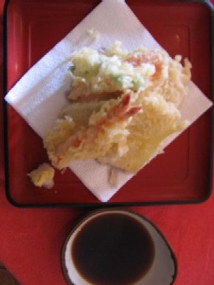

SUNSHINE ANNOUNCEMENT FOR THE WEEK OF 28 JANUARY, 2005;
We clearly need to add some members who were born or wed in this week! No Announcements! No sunshine! Sorry!
*********** MEETING ACTIVITIES:
DATE | ACTIVITY | SUBJECT
28 JAN | CLUB ASSEMBLY | Financials etc
04 FEB | KRISHNA BHATTARAI | Achievements at HRDC
11 FEB | DEEPAK SHERCHAN | TBA
18 FEB | SUMAN THAPA | TILGANGA AND GLAUCOMA ?
25 FEB | open | ---
4 MAR | RAJIV KAFLE | HIV/AIDS

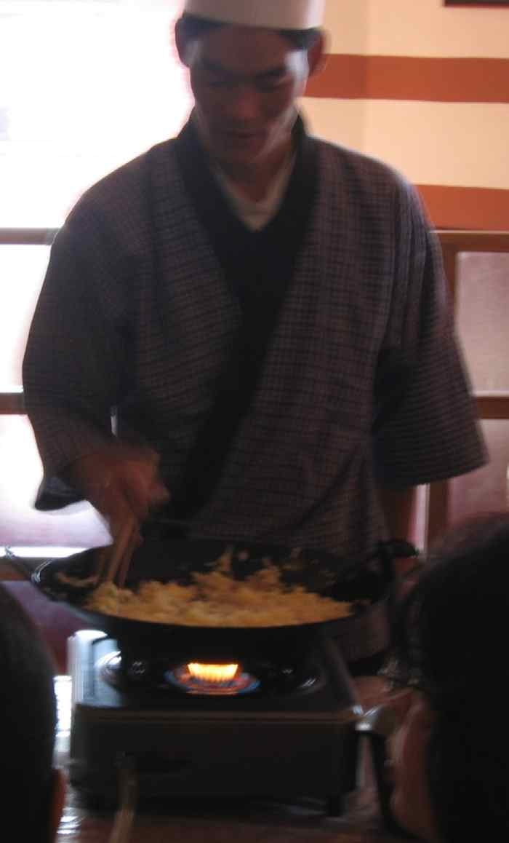
****************
Photos from the gala food study and consumption event are shown here. Just an appetizer for the next event! Thanks to all who contributed to make it a sumptuous success.
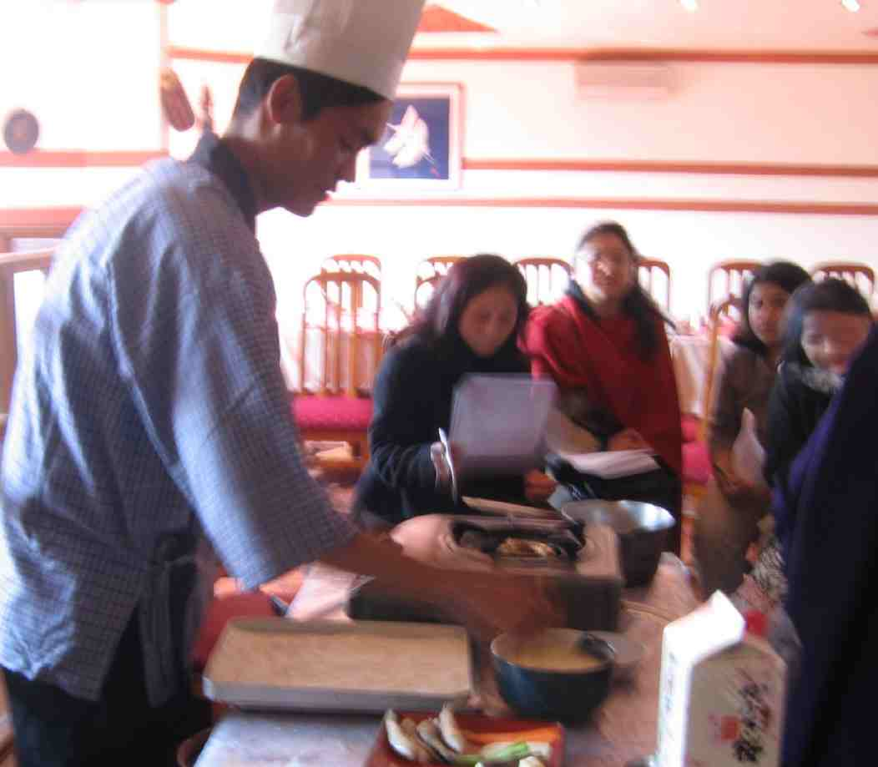
Thanks also to Chandreswori Tamrakar and Chantelle Allen for their explanation of the work by ADRA and the joint program with our club.
****************
This Friday is a Club Assembly. Time to review and preview.
Hope to see you in the morning!

YIR…David

